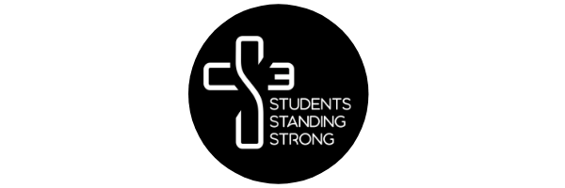

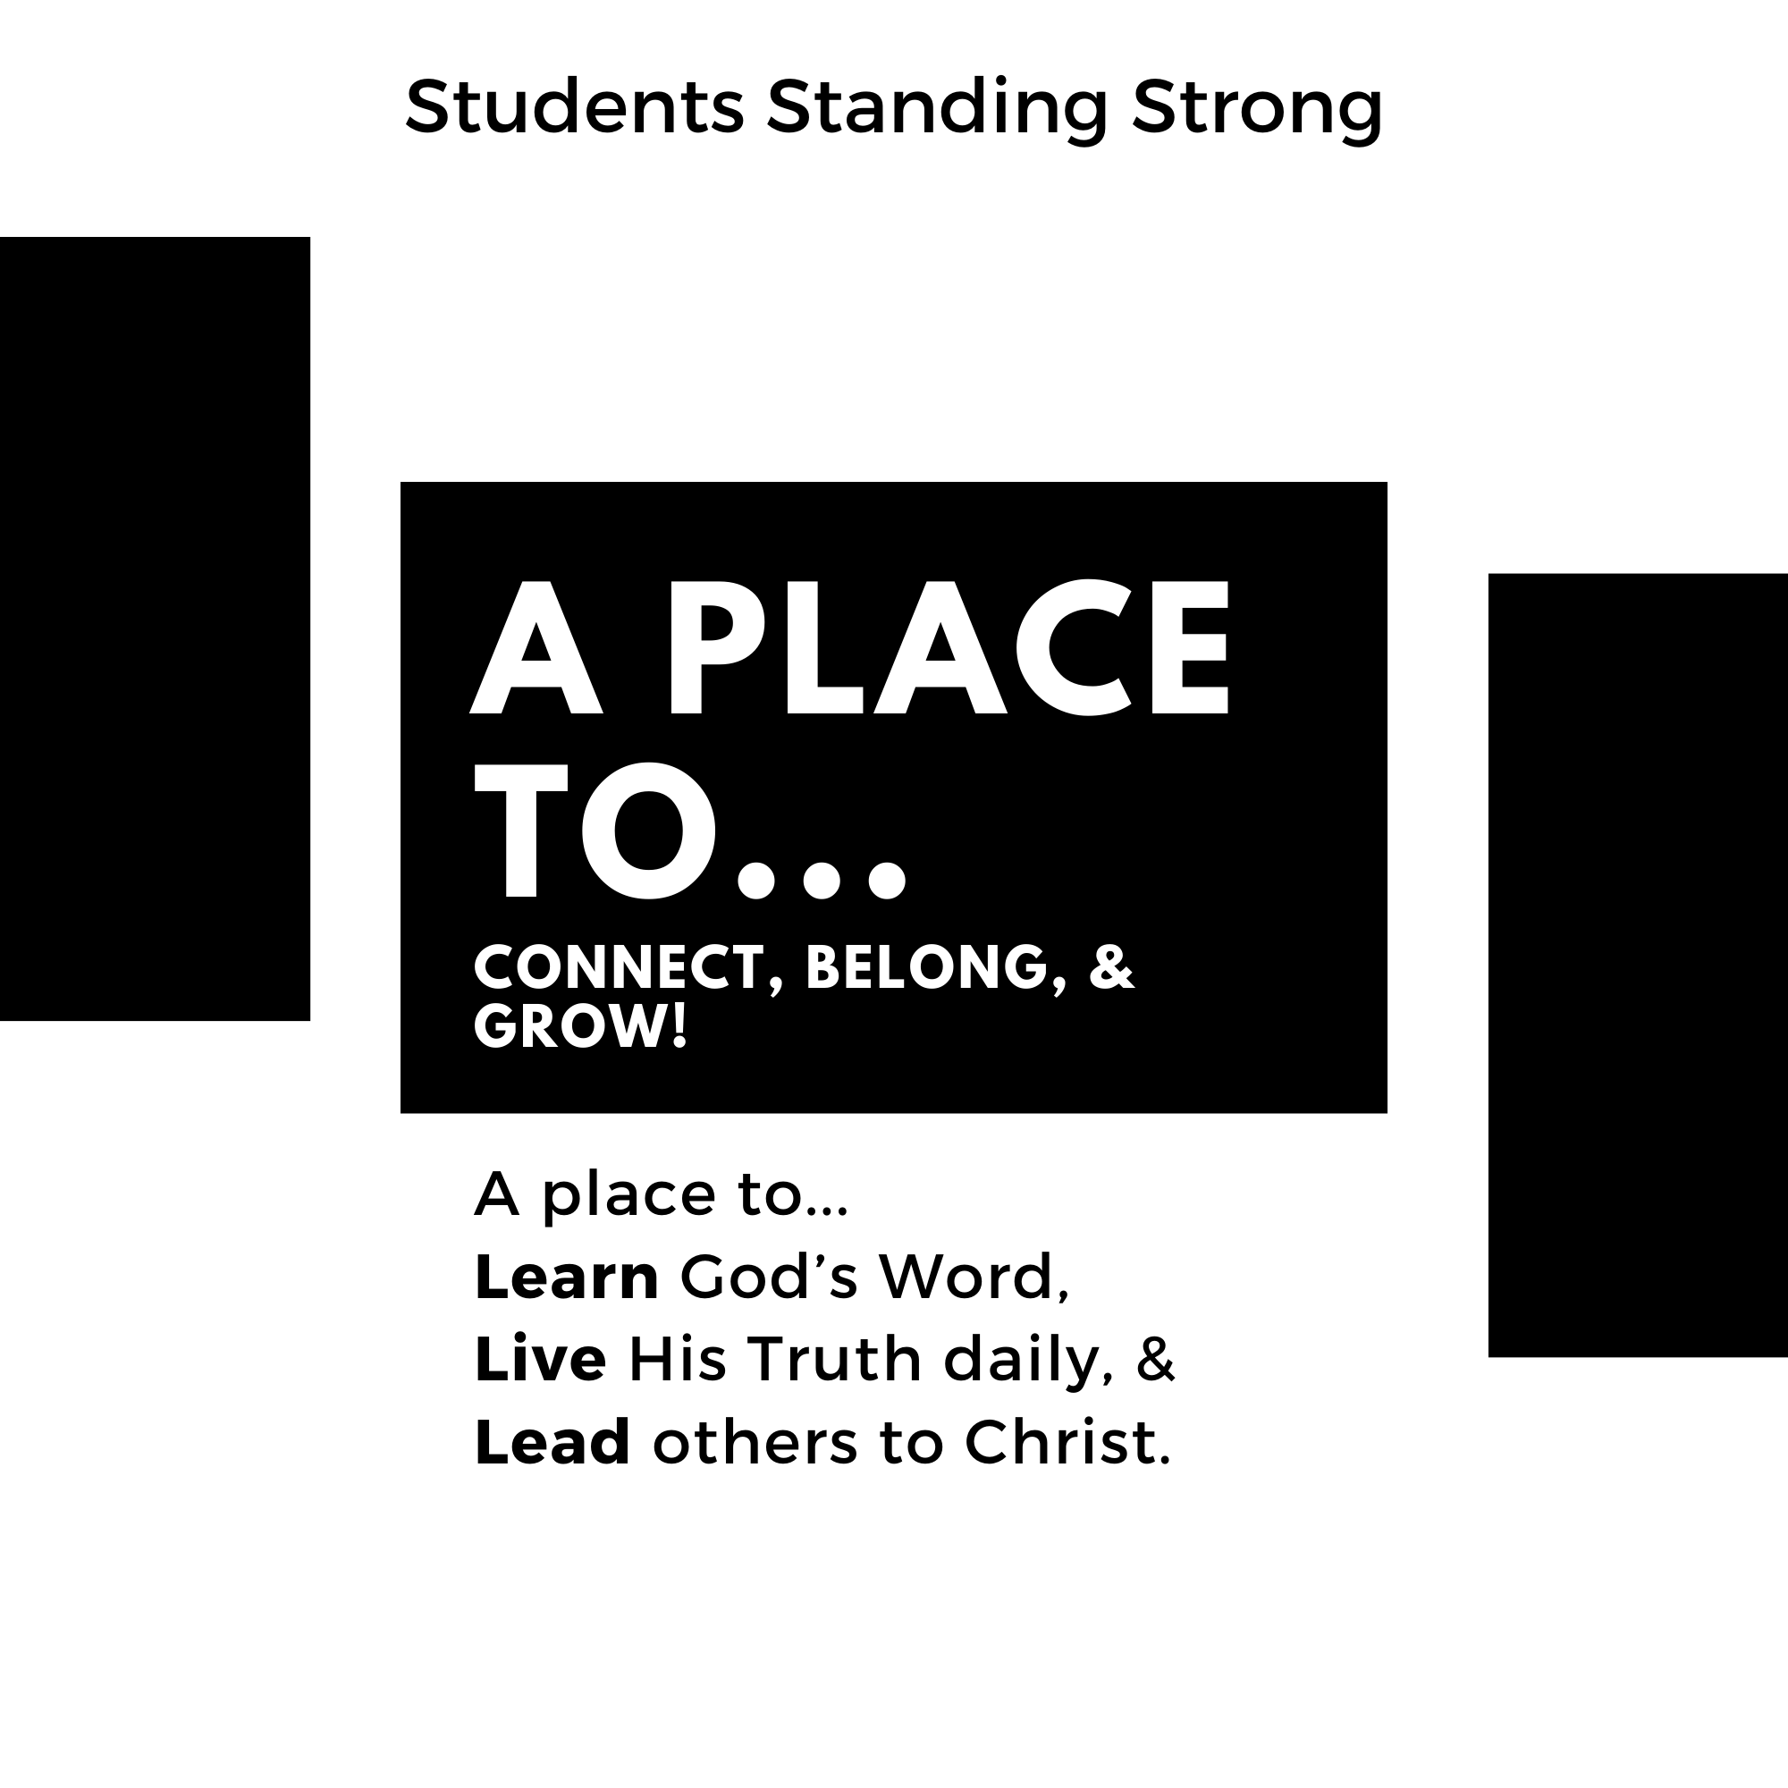

**Time:**

**Place:**

**Contact:**

**\*The school is not responsible for this content**